Data Visualization Project Proposal

Divya Sreenivasan

01570964

**1. Overview**

1.1 Name and URL of Dataset:

* *International Greenhouse Gas Emissions* https://www.kaggle.com/unitednations/international-greenhouse-gas-emissions
* *Climate Change – Earth Surface Temperature* https://www.kaggle.com/berkeleyearth/climate-change-earth-surface-temperature-data

1.2 Domain of Study: Greenhouse Gas Emissions and Climate Change

Greenhouse gases are gases present in Earth’s atmosphere, which absorb and emit radiant energy in thermal infrared range. The primary GHGs (Green House Gases) on Earth are water vapour, carbon dioxide, methane, nitrous oxide and ozone. Hydro-fluorocarbons, Choro-fluorocarbons along with other fluoride gases consist of secondary GHGs . Except water vapour, all other gases are considered to be hazardous in nature when present above a cutoff value. The values of CO2 and Methane, are on an alarming increase from the advent of automobiles, extensive use of fossil fuels (coal, petroleum). These gases heat up the Earth’s atmosphere causing increase in extremely high and low temperatures causing polar ice caps to melt and discomfort to all living organisms.

The Earth’s climate has changed throughout history and with this increasing CO2 and methane emissions; the climate has changed drastically on the negative side. We have created a hole on our protective ozone layer, thereby authorizing Ultraviolet (UV) rays to enter Earth.

In this visualization study, the GHG emissions and climate change are analyzed and interpreted through various visual encodings.

1.3 Dataset and Semantics

The dataset contains Greenhouse Gas Inventory Data of published by United Nations covering a period from 1990 to 2016. The International data consists of anthropogenic (environmental pollutants originating due to human activity) emissions by sources of GHGs (Green House Gases) and fluoride gases. This also includes Land-use, Land-use Change and Forestry LULUCF which is defined by the United Nations Climate Change Secretariat as a “greenhouse gas inventory sector that covers emissions and removals of greenhouse gases resulting from direct human-induced land use, land-use change, and forestry activities.”

The Second dataset contains Earth’s surface temperature data published by Berkeley Earth over a period of time from 1750 – 2010. Here we will consider data from 1990 – 2010. It also includes average temperature uncertainty, which will be considered for analysis.

|  |  |  |
| --- | --- | --- |
| Data | Type | Semantics |
| GHGs  carbon dioxide (CO2),  methane (CH4),  nitrous oxide (N2O),  hydrofluorocarbons (HFCs),  perfluorocarbons (PFCs  Unspecified mix of  HFCs and PFCs,  sulphur hexafluoride (SF6)  nitrogen triflouride (NF3)  Land-use and Land-use Change & Forestry | Categorical, but each has a quantitative value  Ranges from 10000 – 1000000  Expressed in Kilotonne CO2 equivalent | Lines, Color, Shapes |
| Countries | Categorical  Alphabetical order | Color (grouping by region) Maps, position |
| Date (Year) | Ordinal  Ranges from 1990 - 2016 | Lines, |
| Average Temperature  Average Temperature Uncertainty | Quantitative  Ranges from 30 to -20°C | Points, lines |

**2. Detailed List of Tasks**

* What is the trend of GHG emissions over the time period? What does it suggest?
* Is it getting hotter? What about Global warming?
* What does the average surface temperature indicate on Climate Change?
* Effect of GHG emission on Climate Change
* Is there any sudden increase or decrease in trend? Why?

**3. Sketch of Visualization**

3.1 Type of Visualizations

* Line Charts – to represent trends
* Maps – to represent geographic information
* Scatter plot – to represent relationship between GHG emission and Climate Change
* Bar chart – to compare the attributes
* Stacked Column Chart – to exhibit composition over time
* Multiple Views – to view a specific data about a location.

I have rephrased the tasks and updated the sketches in the design sheets. I’m considering a 2D map to visualize as per your advice. Thanks for your feedback.

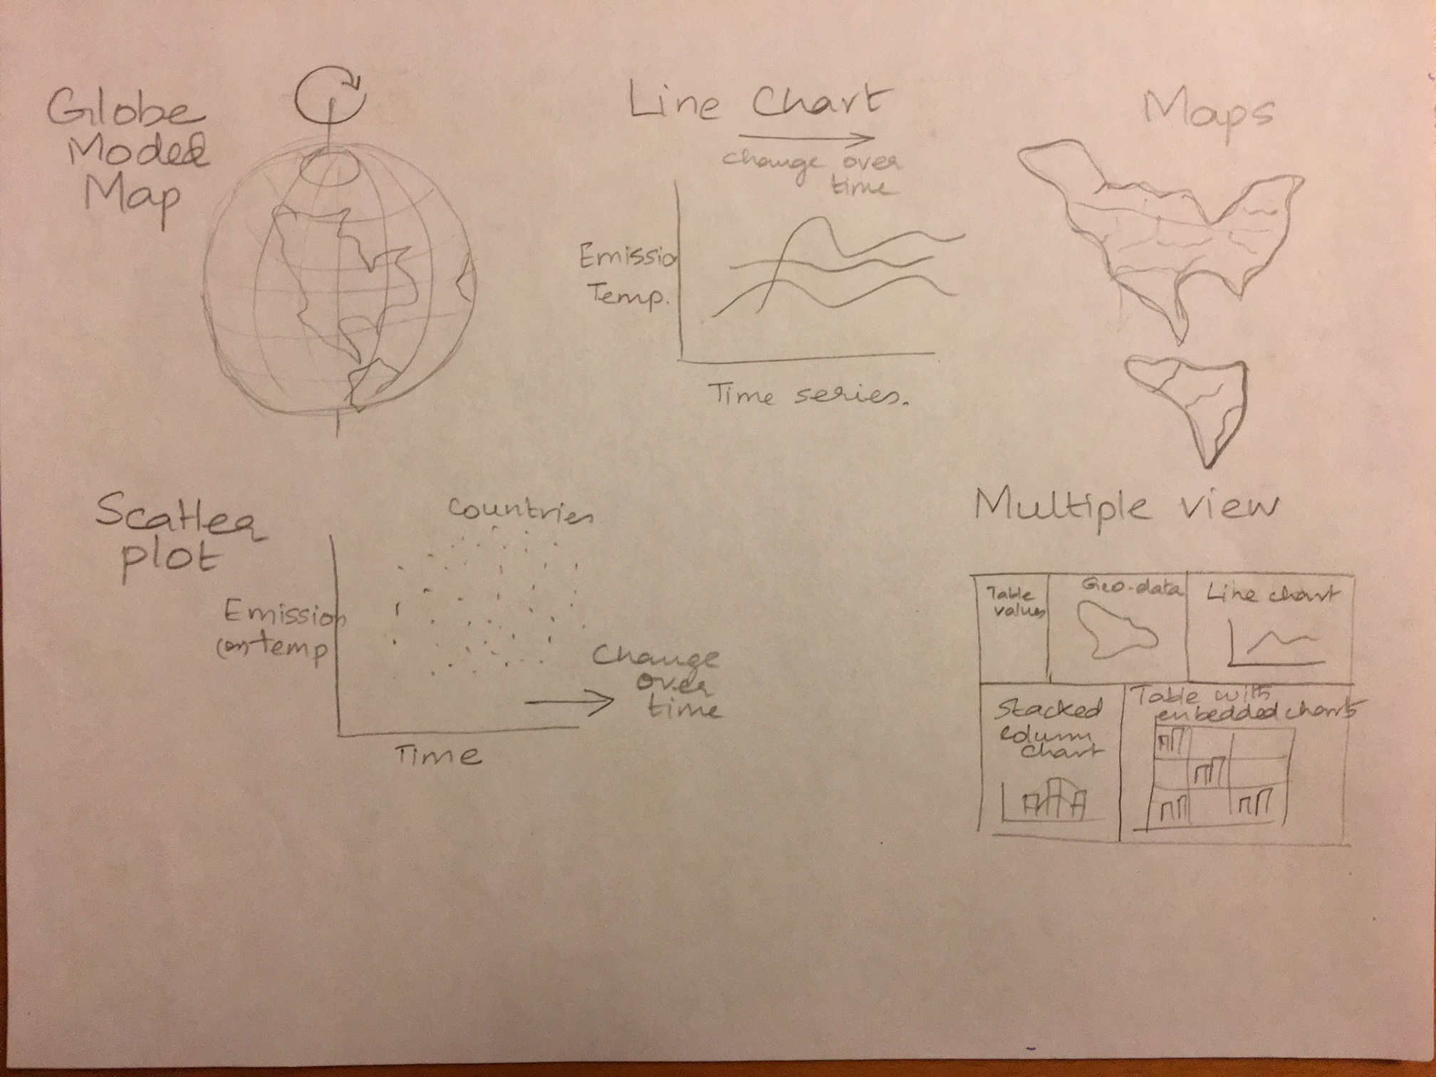

3.2 Collection of Ideas:

* The animation of trends over the years, of both GHG emissions and Earth Surface Temperature.( Transition from one subset of data to another)
* A globe model to represent the earth and implement zoom to interact with the data
* Juxtapose multiple views of data of a specific location upon user request

**4. Reference**

1. [www.kaggle.com](http://www.kaggle.com)
2. “Visualization Analysis and Design” by Tamara Munzer
3. www.gapminder.org/tools